Mutual Funds and Conflicts Concealment among Public Officials at Ohio State
Many judges, lawyers and public officials hold investments in mutual funds in which they have likely received insider tips – Betty Montgomery, case study
What is a mutual fund?
It is an investment program funded by shareholders that trades in diversified holdings and is professionally managed. The SEC states: “A mutual fund is a type of investment company that pools money from many investors and invests the money in stocks, bonds, money-market instruments, other securities, or even cash.”

Public officials must disclose financial holdings and relationships
Public officials are required to disclose their financial holdings annually so that parties relying on their impartiality know when their judgments could be biased by their personal financial interest in one party or the other.

Public officials, conflicts of interest, impartiality, and who gets to choose
When a public official has a financial holding in one of the parties coming before him, that official has a sworn duty to disclose that financial holding to the parties. It is the official’s duty to disclose any matter that might affect that official’s impartiality. It is not the duty of the parties to discover this information; it is the duty of the official to DISCLOSE the information. If the parties mutually agree to allow the official to remain, then that is their choice. However, if either party believes that the conflict could affect that official’s impartiality, then that official must disqualify themselves from participating further.
Former Ohio attorney general Betty Montgomery failed this test in the OSU Marching Band scandal. See below.
The mutual fund shell game
Lawyers have injected into the state and national ethics law a deceptive and vaguely worded exemption from disclosure of the stocks in the mutual fund when the holder “does not personally direct the fund.” This exemption is meaningless because the very act of purchasing the fund is a personal direction to select one fund over the thousands of choices.
Legalized payola
Judges, politicians and bureaucrats all invest heavily in mutual funds. Judges often use the disclosure exemption and fail to disclose when their mutual fund holds stock in one of the litigants. The Judicial Conference lists pages of circumstances where mutual fund stocks must be disclosed. However, judges hide behind their claim not to have to disclose.
Mutual fund managers tip politicians about upcoming boosts in value for particular funds in exchange for favors. This is how politicians and judges can go to Washington and become magically wealthy in a few years.
The mutual fund exemption has become a blanket for insider stock tips
Business and politics have become corrupted by this manipulation of the mutual fund disclosure rules. The have’s benefit from the insider tips, the have not’s pay for it and are the victims.
US ethics law on mutual fund exemptions from reporting has legitimized insider trading among the judiciary, Wall Street and Washington, D.C.
Confront most politicians and judges about the stock held by their mutual funds, and they will claim that they are not required to disclose them. They’ll feign ignorance and say they don’t know what’s in them.
Three telling things that are wrong with that response:
- The person is admitting that he invests in funds without knowing anything about the stocks that comprise them. If this official is really that clueless, then why was he elected to steward your tax dollars? Why is he a judge if he is so careless?
- The person chose certain mutual funds over thousands of choices, so the idea that he is not directing his investing to certain funds and sectors is disingenuous.
- Ethics rules demand disclosure to avoid “even the appearance of impropriety.” In other words, you may not be biased, but the appearance of bias dictates recusal. Therefore, the so-called mutual fund exemption is an empty shell designed to fool the masses, nothing more. It does nothing but give insiders an excuse to trade in their inside knowledge for their benefits and that of their cronies.
The Mutual Fund Scam
Scenario: You are the CEO of ABC company and want to influence a politician. How can you bribe him legally? You tip him off that if he were to invest in XYZ mutual fund; he might see a dramatic boost in that fund’s returns in six months. Wink. Sure enough, in six months your ABC company, which is held by XYZ, goes public, creating a windfall. The politician then sells his shares, and thus becomes addicted to ABC’s insider tips. He’s drunk the Kool-Aid.
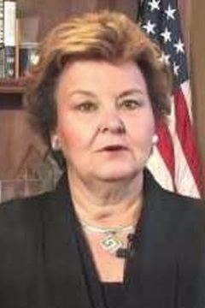
Later on, that politician gives favorable treatment to ABC in return for more insider tip. This is how Washington politicians and federal judges are bribed by Wall Street and grow rich. The mutual fund bribe.
Case Study:
Betty Montgomery, former Ohio Attorney General
Currently heading a Task Force on the Culture of The Ohio State University Marching Band
Betty D. Montgomery, OH Attorney Reg. No. 0007102
Betty Montgomery was chosen by Ohio State president Michael V. Drake and trustee chairman Jeffrey Wadsworth to conduct an ostensibly impartial assessment of the culture of the marching band following the firing of its director, Jon Waters.
Conflict: McBee Strategic
Conflict with Jeffrey Wadsworth and Provost Joseph A. Steinmetz, and 14 of 16 McBee clients who have contracts with Ohio State and MOOC
Montgomery’s’ 2014 financial disclosure shows several investments in BlackRock Global Allocation funds (Stock Symbol: MCLOX). See Betty Montgomery’s 2014 financial disclosure.
The devil in this detail was not hard to find.
Jeffrey Wadsworth is the CEO of Battelle Memorial Institute. One of Battelle’s Washington, D.C. lobbyists is McBee Strategic, LLC, a notoriously known crony firm for Barack Obama. McBee dispensed tens of billions of dollars in green energy stimulus for Obama. In addition, McBee’s clients are major proponents of MOOC (Massive Open Online Course) promoted by provost Joseph A. Steinmetz. These companies include Oracle and Google.
Conflict: JPMorgan Chase
JPMorgan is a client of McBee Strategic, Jeffrey Wadsworth’s lobbyist; they also donate to OSU, hold OSU contracts and support MOOC vendors
McBee Strategic lobbies for JPMorgan Chase & Co. Betty Montgomery holds stock in JPMorgan. JPMorgan is a donor and vendor to Ohio State. JPMorgan participates in The Eclipse Foundation which is heavily promoting MOOC (Massive Open the university equivalent of the controversial Common Core initiative to exert more federal control over education. MOOC is heavily promoted by OSU Provost Joseph A Steinmetz. None of these conflicting interests were disclosed. None of these individuals recused themselves from matters that would be tainted by these conflicts where their decisions would benefit JPMorgan, and therefore Montgomery’s personal financial interests.
McBee Strategic is required by law to disclose the firms who are their lobbying clients. See McBee Strategic Consulting, 2014 Annual Lobbying. The following are McBee clients with known relationships and contracts with Ohio State:
Conflict: Oracle
Oracle is a client of McBee Strategic, Jeffrey Wadsworth’s lobbyist; Google hold OSU contracts and support MOOC vendors
- Alcoa
Conflict: Google
Google is a client of McBee Strategic, Jeffrey Wadsworth’s lobbyist; Google holds OSU contracts and support MOOC vendors
- Babcock & Wilcox
- Battelle
- Boeing
- Charter Communications
- Citigroup
- Eastman Chemical
Conflict: Time Warner
Time Warner is a client of McBee Strategic, Jeffrey Wadsworth’s lobbyist; Time Warner holds OSU contracts and support MOOC vendors
- Enterprise Community Partners
- General Electric
- Google
- Honeywell
- JPMorgan Chase
- National Venture Capital Association
Conflict: National Venture Capital Association
The NVCA is a client of McBee Strategic, Jeffrey Wadsworth’s lobbyist; NVCA members and directors (mutual funds) provide funding to JPMorgan, Time Warner, Oracle, Google, Charter Communications, Citigroup, GE, Honeywell, etc.
- Oracle
- Praxair
- Time Warner
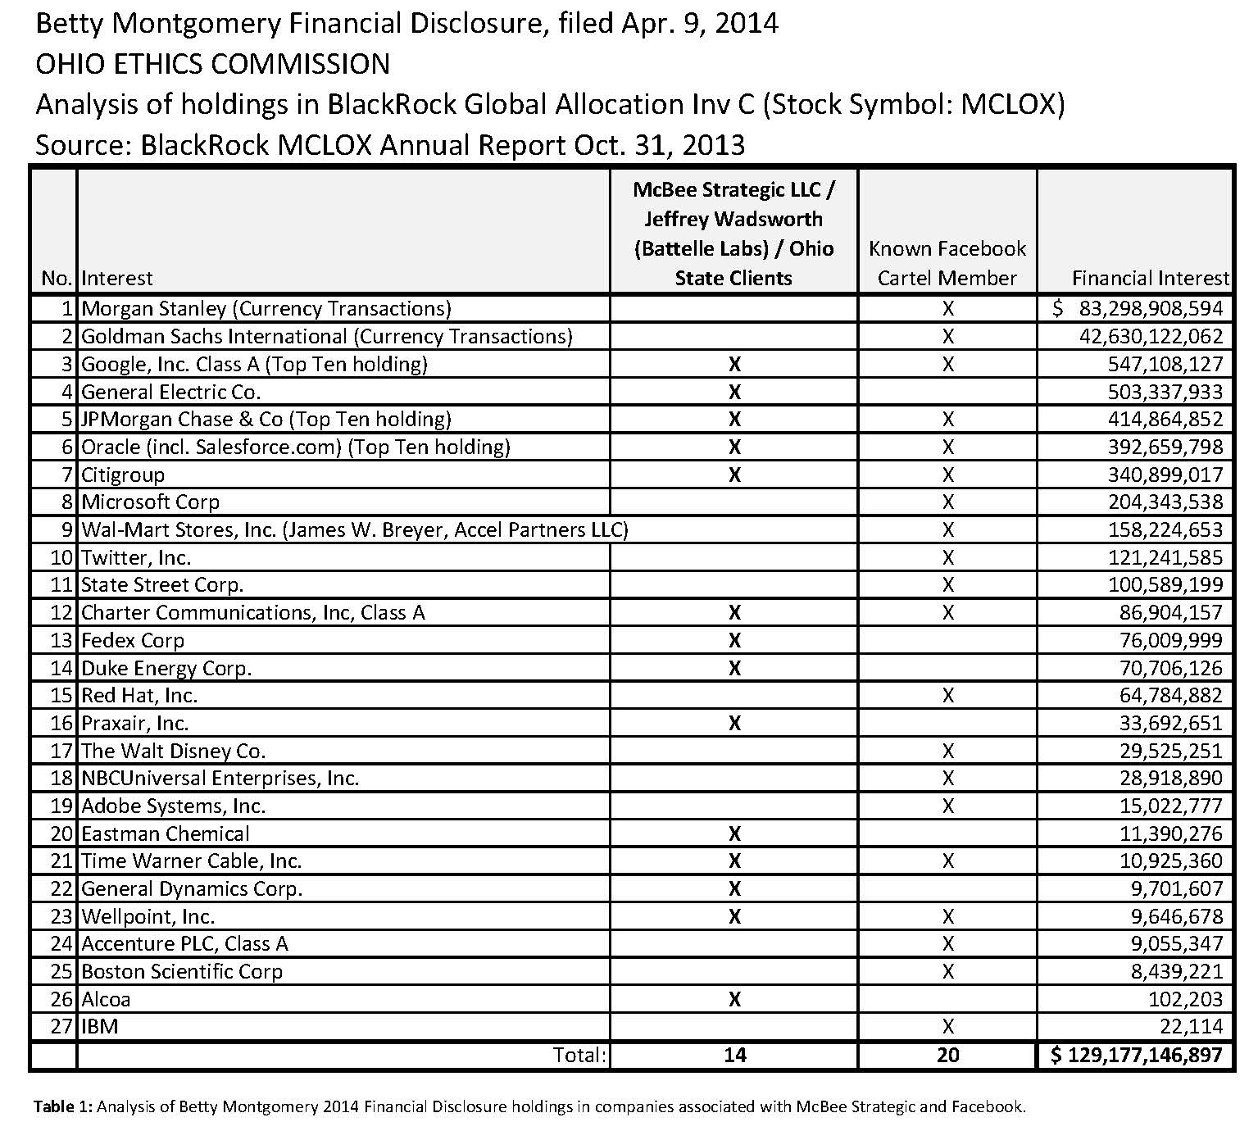

Betty Montgomery failed to disclose that she is invested in 14 of the 16 McBee Strategic clients, who also have contracts and relationships with OSU Trustee president Jeffrey Wadsworth, President Michael V. Drake and the university. In fact, a director for McBee’s Eastman Chemical client, Robert M. Hernandez, is chairman of Montgomery’s BlackRock fund (Stock Symbol MCLOX). Such nondisclosure is against the law. If the nondisclosure was an intentional deception, it is criminal.

In fact, Montgomery even holds stock in Wellpoint, Inc. (see Table 1, No. 23) which donated to her campaign in 2006. Woodrow A. Myers is chief medical officer at Wellpoint, Inc. and is a Stanford black alumni colleague of OSU President Michael V. Drake. See Table 1.
Conflict: Wellpoint, Inc.
Conflict with Michael V. Drake & his colleague, Woodrow A. Myers, Chief Medical Officer, Wellpoint, Inc.
Montgomery’s BlackRock fund last year participated in $83 billion in Morgan Stanley and $43 billion in Goldman Sachs currency trades alone. Both companies are notoriously known to be colluding with McBee Strategic.
Montgomery’s BlackRock holdings conflict with Jeffrey Wadsworth and his McBee Strategic lobbyist. One of McBee’s clients is Eastman Chemical Co. BlackRock MCLOX fund’s Chairman is Robert M. Hernandez, a director of Eastman Chemical Co. Therefore, Montgomery benefits personally from decisions and recommendations favorable to Eastman > McBee > Wadsworth > Ohio State. She is not impartial in any way, shape or form. She is acting unethically and illegally by continuing to be involved in Ohio State matters. Period.
Conflict: Eastman Chemical
Conflict with Jeffrey Wadsworth and his McBee Strategic lobbyist
2.5 billion reasons why Betty Montgomery is biased
Montgomery’s BlackRock fund holds $2.5 billion in shares in the McBee/Ohio State clients listed above. These are 2.5 billion reasons why she failed to disclose her conflicts of interest in the OSU Marching Band Affair. Montgomery is painfully partial to Wadsworth, Drake and Battelle. Her failure to disclose these materially significant holdings may be a criminal in her failure to tell the public that she could not be impartial.
Michael Drake likely shielded Montgomery from liability should these egregious conflicts come to light, as they now have. Fraudulent nondisclosure has no shield from liability.
Montgomery’s excuse could be to try and claim that Ohio ethics law exempts her from disclosure of her BlackRock holdings; claiming that she does not direct the fund, and therefore, does not have to disclose the stocks—even when she holds 14 of the 16 McBee Strategic stocks.
Conflict: Betty Montgomery’s Holdings
Montgomery holds stock in 14 of 16 Jeffrey Wadsworth / McBee Strategic / Ohio State’s clients
We have just illustrated 2.5 billion reasons why such explanations are a gross abuse of the principles of fairness, not to mention common sense. Clearly, one cannot hold stock in 14 of your boss’s 16 crony firms and pretend not to be biased.
This is likely why Washington, D.C. is broken; hidden agendas galore
This abuse of the ethics laws explains why there is so much double-dealing in politics and justice. Our officials are on the make, on a massive, unprecedented scale. For this reason, nothing they do makes sense to us, but it absolutely does to the insiders. This financial double-dealing is why Washington, D.C. is broken.
The Fix
The fix to this mess is surprisingly simple. Require holders of mutual funds to disclose, on a bi-annual basis, the stocks held by their mutual funds. This would require little effort since the funds report their stockholdings bi-annually now.
Require judges to recuse themselves if they hold even one share in a litigant. Require the same of politicians and bureaucrats. This simple requirement will allow citizens to easily check to see if the official has interests that require his or her disqualification from a matter.
* * *
Postscript
Suddenly, Betty Montgomery’s unpaid status is being emphasized by the university. According to Ohio ethics law, unpaid consultants are not required to file personal financial disclosures. This appears to be the reason her status has suddenly become important—to skirt the Ohio Ethics laws. Nonetheless, her prior positions within the State of Ohio caused her latest financial report to be released. No public official can be shielded from liability when they have acted fraudulently.
An attorney rarely works for a well-funded institution like Ohio State for months without compensation. Is Montgomery getting compensation from her cronies? BlackRock, Arent Fox LLP, David Vaughn Consulting Group, or from a magical new clients of her law firm, MacMurray Petersen & Shuster LLP, 6530 West Campus Oval, Suite 210, New Albany, OH 43054, (614) 939-9955? Call them and ask. Tellingly, clients of attorney firms can be confidential, so it is not likely that she will disclose her magical new client(s). Attorneys appear to have created an out for every situation that could get them in trouble… except for fraud.

Betty Montgomery 2014 Financial Disclosure, http://www.fbcoverup.com/docs/ohiostate/2014-04-09-Montgomery-Betty-Financial-Disclosure-Apr-09-2014.pdf
McBee Strategic 2014 Lobbying Clients, http://www.fbcoverup.com/docs/ohiostate/2014-08-09-McBee-Strategic-Consulting-2014-OpenSecretsLobbying-Spending-Database-accessed-Aug-09-2014.pdf
BlackRock Global Allocation Inv C Annual Report, Oct. 31, 2013, http://www.fbcoverup.com/docs/ohiostate/2013-10-31-MCLOX-BlackRock-Global-Allocation-Inv-C-Annual-Report-Oct-31-2013.pdf
Wellpoint, Inc. Political Donations, 2006, Betty Montgomery, p. 3 http://www.fbcoverup.com/docs/ohiostate/2006-WELLPOINT-INC-Follow-The-Money-Political-Contributions-2006.pdf

