Oct. 29, 2014—Email received from a certified public accountant (CPA) who was asked by AFI investigators to evaluate the investing authority granted to certain officers of The Ohio State University whose titles are identified in the following paragraphs contained in the following AFI post:

“Ohio State Trustees Approve Crony Investments in JPMorgan & Facebook While Abusing Their Marching Band & Social Networking Inventor” by AMERICANS FOR INNOVATION, Oct. 28, 2014 http://americans4innovation.blogspot.com/2014/10/ohio-state-trustees-approve-crony.html

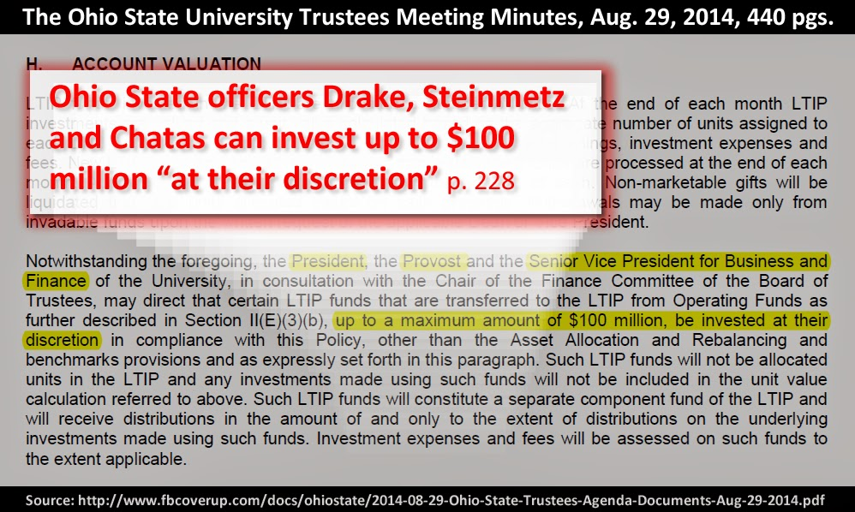

URL: http://www.fbcoverup.com/docs/ohiostate/2014-08-29-Ohio-State-Trustees-Agenda-Documents-Aug-29-2014.pdf#page=228

Email Response:
From: Kim Mattice [mailto:KMatticeCPA@matticecpa.com]
Sent: Wednesday, 29 October, 2014 4:21 PM
To: mmckibben@leader.com
Subject: RE: Your professional opinion sought on Ohio State trustee investing authority document

Mike ,

This paragraph is not complete; however, this is what I believe they are stating:

- The three (3) individuals mentioned, in connection with the chair of the finance committee, may invest funds however they choose up to $100 million.

- The paragraph is not specific as to whether the three (3) must act together or if they can act separately with the chair of the finance committee?

- There are apparently existing Asset Allocation and Balancing Benchmarks with respect to the investment of these funds.

- Nevertheless, if any of the three (3) determine to specify that they choose to disregard the Asset Allocation and Balancing Benchmarks which are in place, they may do so to the extent of $100 million.

- In actuality, it does not specify if the $100 million is, per investment, or in the aggregate? Accordingly, who knows if they have the right to invest only $100 million, in the aggregate, outside of the Asset Allocation and Balancing Benchmarks or if it is per investment and unlimited?

- These specific investments by the three (3) individuals mentioned will not be considered in the evaluation of the investment of the funds with respect to the Asset Allocation and Balancing Benchmarks that are in place.

- Accordingly, they may invest in Florida Swamp Land, Moon Rocks, Related Party Transactions, or whatever else they unilaterally deem appropriate.

- Essentially, there is no oversight or accountability for these specific investments to comply with the established guidelines and stratification of invested funds, as outlined in the existing Asset Allocation and Balancing Benchmarks.

The language is not specific, it is very broad and without bounds; accordingly, they have been given license to invest in whatever they choose with no accountability with respect thereto.

It is very unusual that the board of trustees would grant such powers which disregard the parameters and guidelines which apparently already exist in the applicable rules, regulations, and by-laws of the entity as to the structure and accountability for the investments along with the stratification normally required.

It appears that the Asset Allocation and Balancing Benchmarks were established to provide guidance and investment prudence, accountability, and measured performance for each investment unit of the fund with the costs and expenses being specifically allocated to each unit of investment to measure “Net” performance.

This license to invest, granted to the individuals mentioned, will not be measured, accounted for, or restricted predicated upon the existing Asset Allocation and Balancing Benchmarks which are in place.

“A Blank Check” is the correct name for what has occurred.

Be Brave & Keep Smiling.

Kim W. Mattice, CPA
KIM W. MATTICE, CPA, LTD.
P.O. Box 63
1546 East White Mountain Blvd.
Pinetop, Arizona 85935

Telephone: 928-367-1515
Facsimile: 928-367-0880

E-mail: kmattice@matticecpa.com
Web: www.matticecpa.com

Internal Revenue Service Circular 230 Disclosure: As provided for in Treasury regulations, advice relating to federal taxes that is contained in this communication (if any), including attachments, is not intended or written to be used, and cannot be used by any taxpayer for the purpose of: (1) avoiding penalties under the Internal Revenue Code or (2) promoting, marketing or recommending to another party any plan or arrangement addressed herein.
Confidentiality Notice
This electronic mail transmission and any accompanying documents contain information belonging to the sender which may be confidential and legally privileged. This information is intended for the use of the individual or entity to whom this electronic mail transmission was sent as indicated above. If you are not the intended recipient, any disclosure, copying, distribution, or action taken in reliance on the contents of the information contained in this transmission is strictly prohibited. If you received this transmission in error, please call me collect at 928-367-1515 to let me know and delete the message. Thank you!

