Outraged Buckeye Nation sparks whistleblowers
New evidence reveals collusion among certain OSU Trustees to cheat the Ohio State grad who invented social networking,
(Aug. 19, 2014)― Buckeye Nation is outraged by the firing of beloved OSU Marching Band Director, Jon Waters. Despite the public outcry against the decision, Ohio State Trustees president, Jeffrey Wadsworth “stands firmly” behind the decision.
Whistleblowers have come forward with important new revelations about this misconduct.
Is the attack on Director Jon Waters and the famed OSU Marching Band a Title IX diversion gone wrong?Some insiders suggest that the trustees sacrificed Waters to divert attention from Athletic Director Gene Smith’s botched Title IX investigation of the OSU Cheerleaders. See “Gene Smith mum,” The Lantern, Feb. 27, 2014.
I would mention the article but leave out the next part. It’s already long, and the allegation is already out there. People can read the Lantern article if they want. I don’t find Gene Smith a very compelling reason. His involvement is speculative; the stuff at the end of the article is fact. I would eliminate the next two paragraphs and the header.
Diversion from Gene Smith’s botched Title IX investigation?
The Title IX coordinator in the Gene Smith affair, Andrea Goldblum, left her position shortly after Smith fired the coaches, including Lenee Buchman, but Goldblum now gives innocuous reasons for her departure that lack credibility. Neither Michael V. Drake nor Jeffrey Wadsworth had prior experience with the OSU band’s storied tradition. By contrast, Drake’s Stanford band can best be described as quirky. So, it appears that Drake & Co. decided to sacrifice Jon Waters to salvage Gene Smith’s career; assuming any backlash would be short lived.
It also appears that Drake & Co. played upon the historical jealousy of the OSU School of Music over the Marching Band’s popularity in order to get the cooperation of the provost, Joseph E. Steinmetz, and the music school directors, Richard L. Blatti and Russel C. Mikkelson. Waters had just generated $30 million for the music school from the Apple iPad commercial. Waters was a highly productive innovator who was showing them up in this internecine musical rivalry.

This is a red herring. Not germane.
Actors in this OSU scandal
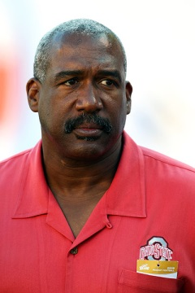 | 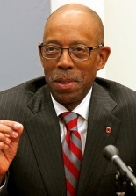 | 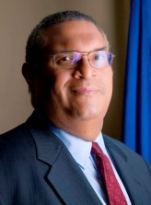 |  | 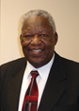
Gene Smith | Michael V. Drake | Woodrow A. Myers | Jeffrey Wadsworth | James P. Chandler
OSU Athletic Director | OSU President; Stanford Black Alumni award winner | CMO, Wellpoint, Inc.; former CCO, Anthem Blue Cross Blue Shield; Stanford Black Alumni award winner | OSU Trustee President; CEO, Battelle Memorial Institute; Dep. Dir. Sci. & Tech., Lawrence Livermore National Laboratory (LLNL);  client of McBee Strategic LLC, Facebook’s Cooley Godward LLP partner | National Intellectual Property Law Institute, Pres.; Leader Technologies’ former attorney; author of Trade Secrets Act and EEA; adviser to White House, Congress, DoE, NSA, CIA, FBI, Justice Dept.; industry; adviser to OSU’s Maurice Clarett; the former Harvard Law professor
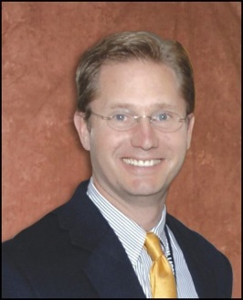 |  | 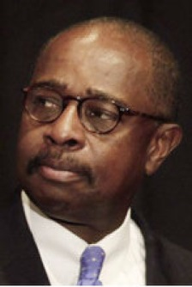 | 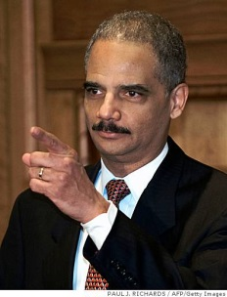 | 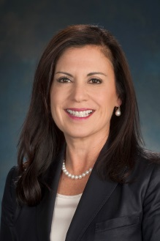
Alex R. Fischer | Chris Glaros | Algernon L. Marbley | Eric H. Holder | Lori Barreras Fischer
OSU Trustee; former Sr. VP, Battelle; former Chairman, Omniviz | Author of Waters Report; Chief Counsel, Children’s Defense Fund; former law clerk to Marbley and Holder | OSU Trustee; mentor to Glaros and Barreras | U.S. Attorney General; mentor to Glaros; long-time collaborator to Chandler; Harvard Law grad | Commissioner, Ohio Civil Rights Commission; sworn in by Marbley; married to OSU Trustee Fischer; former VP of HR for Wadsworth at Battelle
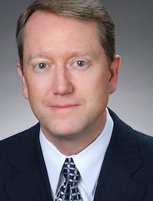 | 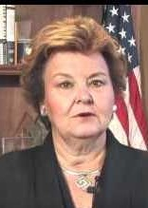 | 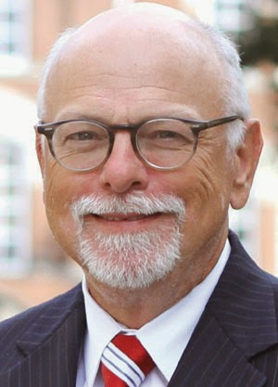
David Vaughn | Betty Montgomery | Joseph A. Steinmetz
Drake probe; Criminal Attorney; former Asst. U.S. Attorney under Eric Holder; UC, Stanford and Harvard grad | Drake probe; former Ohio Attorney General; recipient of Myers/Wellpoint, Inc. political donations | OSU Provost; MOOC cheerleader; OSU School of Music boss; Jon Waters’ boss

The mistreatment of Jon Waters shined a light on the corrupt agenda of some OSU Trustees: All roads wind back to Jeffrey Wadsworth and Battelle Memorial Institute
We reached out to Leader Technologies in Columbus, Ohio for background on their past relationships to Battelle and Lawrence Livermore National Laboratory (LLNL). We received a treasure trove of evidence tying Jeffrey Wadsworth, and his former VP, Alex R. Fischer, to the misappropriation of Leader’s invention for social networking.
Ironically, Leader’s Chairman and Founder, Michael McKibben, was a four year member and squad leader of TBDBITL (“The Best Damn Band in the Land”). McKibben knows Jon Waters and said Waters is one of the University’s most credible ambassadors. He pointed to Waters’ work with the Ohio School for the Blind as an example. Waters prepared them for the first-ever appearance of a blind marching band in the Tournament of Roses Parade on Jan. 1, 2010. McKibben said, “An incompetent, uncaring person doesn’t do that. Jon Waters is a person that the Ohio State administration should be heralding and affirming, not firing.”
We’ll start with information that stunned even Leader, who had not previously made the association.
In 2002, Wadsworth, Battelle and LLNL promised to protect Leader Technologies’ secrets, yet appear to have helped give it to Zuckerberg and IBM’s Eclipse Foundation / MOOC
Three sets of Leader documents stood out:
- a 2002 contract between Leader and LLNL, signed by Wadsworth himself. See Fig. N below.
- a 2002 Leader-Battelle email string and business plan PowerPoint proposing Harvard University Initiative (18 months before Facebook started) and naming Fischer’s Battelle subsidiary, Omniviz; and
- Thirty-seven (37) 2002 nondisclosure agreements signed by Battelle and LLNL personnel promising to protect Leader’s intellectual property from disclosure without Leader’s permission. See Battelle/LLNL nondisclosure agreement folder.
LLNL-LEADER CRADA – [Jeffrey Wadsworth]
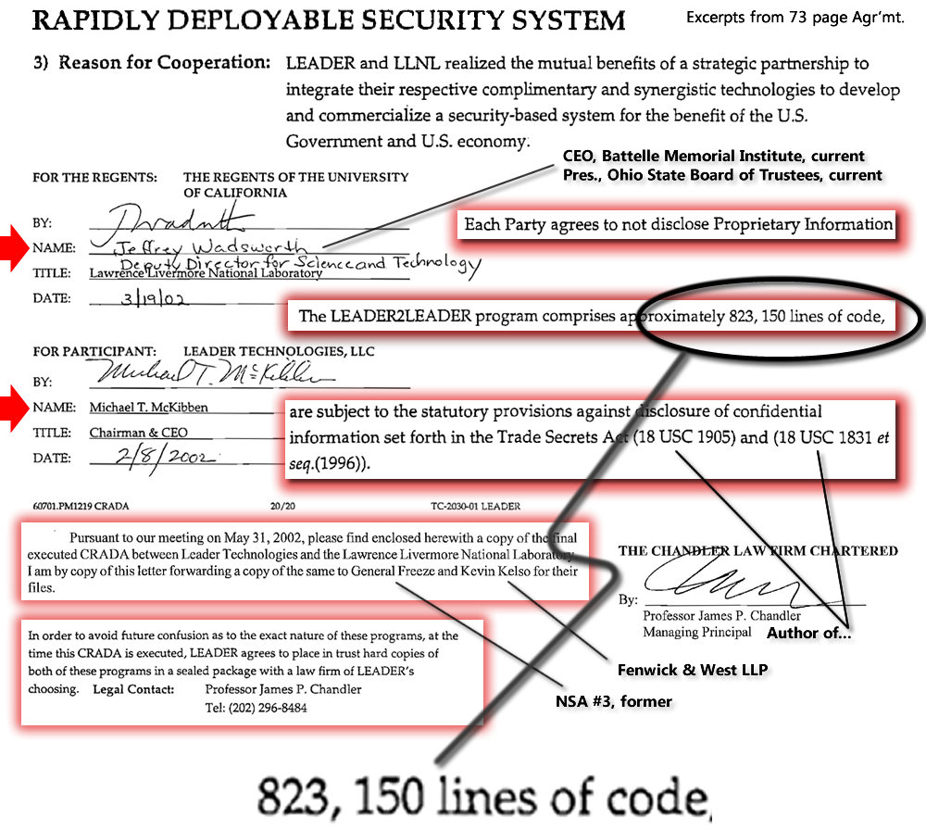
Full Circle – Back to OSU Provost Joseph E. Steinmetz
Now we have come full circle, back to the data point that triggered this investigation:
OSU Provost Joseph E. Steinmetz’s May 2013 article for the Association for Psychological Science promoting MOOC (Massive Open Online Course) – a conception for worldwide global education networking promoted by IBM’s The Eclipse Foundation.
Steinmetz’s writings led us to an examination of MOOC vendors at Ohio State, including Oracle and Google. Those vendors led us to look into OSU Trustee Jeffrey Wadsworth’s lobbyist, McBee Strategic, and the 12 plum contracts by McBee clients at OSU. McBee’s alliance with Facebook’s Cooley Godward LLP on the failed energy stimulus raised the specter of likely OSU corruption even higher.
The uncanny connection among Wadsworth/Battelle, McKibben/Leader Technologies and the Battelle/LLNL misappropriation of McKibben’s invention into the hands of Zuckerberg, IBM, The Eclipse Foundation and MOOC just popped out!

I think this is beneath you.
More proofs of collusion:
The OSU Trustees’ inter-relationships are convoluted, so stick with us.
Chris Glaros is the author of the Waters “sexualized culture” report. Glaros attended Columbia and Stanford. He clerked for then Assistant Attorney General Eric H. Holder, and for Judge Algernon L. Marbley, Southern District of Ohio (Columbus). At the time of his Holder clerkship, Professor James P. Chandler was working closely with Holder and the Justice Department on trade secrets and economic espionage. Chandler even cites Holder in a Mar. 28, 2001 trade secrets conference he sponsored.
Algernon L. Marbley is an OSU Trustee and Southern District Court judge in Columbus. He attended UNC and Northwestern and has taught at OSU and Harvard. He mentored Chris Glaros and swore in Lori Barreras Fischer as an Ohio Civil Rights Commissioner.
Lori Barreras (aka Lori Barreras Crouch) is married to Alexander R. Fischer, appointed OSU Trustee on Jul. 3, 2014, just 11 days before the Waters firing. She was appointed to the Ohio Civil Rights Commission on Oct. 31, 2013 where she was sworn in by Algernon L. Marbley. She most recently served as Asst. VP of Human Resources at OSU. Prior to that she was VP of HR at Battelle, employed by Jeffrey Wadsworth, CEO of Battelle. Barreras attended the Univ. of Arizona
Alex R. Fischer is an OSU Trustee, appointed just 11 days before the Waters firing on Jul. 24, 2014. Fischer was Sr. VP at Battelle, including chairman of a Battelle company, Omniviz. Fischer’s boss was Battelle CEO, Jeffrey Wadsworth. Fischer is married to Lori Barreras and served as VP or HR for Battelle under Wadsworth. Fischer attended Tennessee.
Gene Smith is OSU Athletic Director whose Title IX scandal involving the OSU cheerleaders has dropped off the headlines in the wake of the evidently fabricated Jon Waters OSU Marching Band accusations. Smith attended Notre Dame. (Smith’s problems were in February, and I didn’t hear anything about them, so were they in the headlines? And since the Waters firing is so much later, I don’t think it’s credible to say that one was an effort to deflect the other one. )
Jeffrey Wadsworth is president of the OSU Trustees and CEO of Battelle Memorial Institute. Wadsworth attended Sheffield in the UK and worked for the University of California Trustees at Lawrence Livermore National Laboratory (LLNL).
Michael V Drake is president of Ohio State. He attended Stanford. (you have evidence?) is Woodrow A. Myers whose company Wellpoint, Inc. has spread around political donations liberally in Ohio since 2006, including gifts to Betty Montgomery, whom Drake has appointed to the Waters commission. Drake has failed to disclose that his other choices for the Jon Waters probe, Arent Fox LLP and David Vaughn, are equally conflicted. See previous post.
Conspiracy to exploit the social networking invention exposed
On Mar. 19, 2002, Jeffrey Wadsworth, then Deputy Director at Lawrence Livermore National Laboratory (LLNL), signed a research and development agreement with Michael McKibben, founder of Leader Technologies.
Copied on that agreement were Leader’s patent attorney and director, Professor James P. Chandler; Major General James E. Freeze (U.S. Army ret.), former #3 at the National Security Agency (NSA); and Leader’s corporate attorney, Kevin Kelso, Fenwick & West LLP.
That agreement, written by Chandler, contained an Appendix C provision whereby Leader “place in trust” hard copies of this LEADER2LEADER invention comprised of “823,150 lines of code.” Programming code is the software version of a book manuscript. Each line is roughly equivalent to a sentence of writing. A good programmer can produce about 200-300 lines of code a day.
The purpose of the agreement was to prove-out McKibben’s (social networking) invention for use in U.S. government applications as a “Rapidly Deployable Security System.”
Battelle elicited the contact with Columbus-based Leader Technologies
On Feb. 21, 2002 Battelle proposed a meeting to explore a business alliance with Leader and a Battelle company named Omniviz. Three weeks later, on Mar. 29, 2002, Leader prepared a 50-page business plan. That plan included a proposed IBM and Harvard in a “University Initiative” with Battelle.
Three months earlier, on Nov. 29, 2001, IBM and Chandler, with the help of Fenwick & West LLP, had created The Eclipse Foundation with source code whose authorship they were “unable to determine” eighteen months later. That source code from Leader Technologies forms the foundation of the current global education initiative named MOOC. See previous post.
Ohio State’s Provost Joseph E. Steinmetz sang the praises of MOOC in an article for the Association for Psychological Sciences in May 2013 after which Ohio State embraced its MOOC vendors, including Google and Oracle.
Steinmetz is the boss of the OSU School of Music which was quick to swoop in to run the band following the Waters firing. The jealousy of the School of Music toward the popularity of the marching band is well-known and deep-seated. Steinmetz appears to have thrown the Music School leadership Richard L. Blatti and Russel C. Mikkelson a bone for not yet known favors.
MOOC evidently had its origins in the Mar. 29, 2002 Leader PowerPoint business plan created by Michael McKibben for Leader’s business opportunity discussions with Battelle.
Facebook’s true origins
This new evidence validates long-held suspicions of widespread collusion among participants in the “Facebook Cartel.” Battelle was long suspected of involvement, but proof was elusive, until the Jon Waters band scandal focused attention on the OSU Trustee President, Jeffrey Wadsworth.
Leader had the idea for a Harvard University Initiative involving IBM and Battelle two years before Facebook went live on Feb. 4, 2004—while Zuckerberg was still in high school.
Alex R. Fischer and Omniviz
On Jul. 3, 2014, Alex Fischer was appointed to the OSU Board of Trustees. His official biography says he was Chairman of Omnviz. However, on Feb. 21, 2002, Leader Technologies prepared a business plan with Battelle-Omniviz for their confidential business discussions.
In addition to the PowerPoint that specifically mentioned Omniviz, Leader also provided a copy of email correspondence showing that Omniviz participated in confidential business discussions with Leader on Feb. 25, 2002. Those Omniviz discussions were protected by the nondisclosure agreements. ANY unauthorized use of that information for the benefit of Battelle or Omniviz was prohibited.
According to Leader, no one from Battelle or LLNL past or present has ever contacted Leader to license their intellectual property.
Fischer and Battelle went on the commercialize Omniviz and sold the company on Jan. 29, 2007.
AFI had previously received reports that Zuckerberg had a copy of a Leader PowerPoint, but this is our first view of the actual document. It is no wonder that the boy wonder could move so quickly, Leader had already produced “823,150 lines of code” and placed it “in trust” with Chandler, who proceeded to supply it to Jeffrey Wadsworth.
Facebook’s attorneys lied to the court in the Leader v. Facebook patent infringement case that started on Nov. 19, 2008. They told the court they lost ALL of Zuckerberg’s hard drives and Harvard emails from 2003-2004. Yet magically, just two days after the Federal Circuit supported a verdict for Facebook based on fabricated evidence never put before the jury, Facebook’s attorneys magically “found” 28 Zuckerberg hard drives and emails. Imagine that. They are clearly hiding these connections to IBM, Battelle, Chandler, Wadsworth, etc.
Prediction – OSU Information Technology “Reorganization”
If OSU allows President Michael V. Drake to remain in office after this Waters debacle, we predict that Drake will announce a reorganization of the OSU Information Technology Office. This will enable his MOOC friends to finish laying their digital pipelines at OSU without interference from “old fashioned” privacy- and security-minded technologists, which were likely blocking their agenda.

